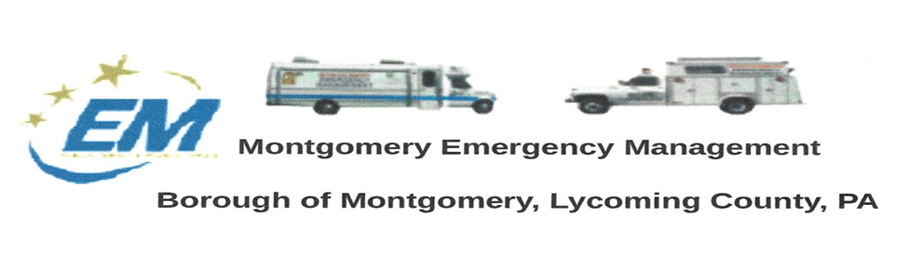
Greg Gruver, EMA Coordinator. 77 East Houston Avenue, Montgomery, PA 17752
Greg Gruver, EMA Coordinator. 77 East Houston Avenue, Montgomery, PA 17752
Telephone: 570-547-1212 Cell: 570-419-4866 Email: monteman61@gmail.com
Fae Herb, Administrative Assistant. 102 Broad Street, Montgomery, PA 17752
Cell: 570-506-9892 Email: faeherb@aol.com
Meeting Room and Equipment Building: 40 Thomas Avenue, Montgomery, PA 17752
Borough EOC: 570-547-1671 Fire Hall EOC: 570-547-1380
INTERNET WEBSITE: www.montgomeryboroughema.org

Telephone: 570-547-1212 Cell: 570-419-4866 Email: monteman61@gmail.com
Fae Herb, Administrative Assistant. 102 Broad Street, Montgomery, PA 17752
Cell: 570-506-9892 Email: faeherb@aol.com
Meeting Room and Equipment Building: 40 Thomas Avenue, Montgomery, PA 17752
Borough EOC: 570-547-1671 Fire Hall EOC: 570-547-1380
INTERNET WEBSITE: www.montgomeryboroughema.org

THE NEXT REGULAR MEETING of the Montgomery Borough Emergency Management Agency will be:
THURSDAY, JULY 14, 2022 AT 7 P.M.
REFRESHEMENTS WILL BE PROVIDED BY ED FERGUSON
NOTES FROM ADMINISTRATIVE ASSISTANT, FAE HERB

As we emerge from post-COVID, community events are planned and well attended. Events such as the Fishing Derby, First Annual Riverfest, Memorial Day service and recently the Montgomery Firemans Carnival and July Fireworks. Members of the Montgomery EMA having taken part in these events. The Community came together and supported a family that last their home and three pets to a devasting fire. With monetary donations, gift cards, clothings as well as prayers of support. Where would we be without Volunteer services….VOLUNTEERS ARE ALWAYS NEEDED, THEY ARE TRAINED AND PREPARED. NO MATTER YOUR AGE, YOU CAN HELP.
It was wonderful to see the park filled with spectators to watch the July Fireworks. We were busy right up to the National Anthem with sales. Big thanks to Craig E. Miller and Greg Gruver for the soundsystem. Thanks to our EMA volunteers who helped.
Upcoming events include our EMA volunteers with radio experience to help man the Lycoming County Sheriff’s shed at the Lycoming Fair, July 13-23. Greg Gruver, Dennis Gruver, Dale Brendle and Ed Ferguson have signed up. Monday, July 25th, Joe Snedeker, meteorologist for WNEP-TV 16 will be riding his bike into Montgomery for his GO JOE, 25th Anniversary Bike Ride for St. Josephs Center. Raising money to help those with mental and physical disabilities. Broadcast is scheduled for noon in Montgomery, location is unclear as of yet, EMA is planning to take IMU to location.
If you are interested in becoming a member of the Montgomery Borough EMA, attend our meetings. Second Thursday, of every month, 7 p.m. at 40 Thomas Avenue. Trailer sits behind the EMA garage.

